Contents
2. Overview 1
3. General 2
4. File naming convention 3
5. File Format: 4
6. top-level section 5
7. nodeParameters section 7
8. nodeVariables & eventVariables sections 8
10. Overloaded labels 16
11. Logic elements 18
12. Replaceable Tokens 20
13. Channel Names 21
14. Examples 24

Overview
The CBUS protocol provides commands to allow the configuration of a module by a networked computer. These commands allow the read & write functionality of numbered variables, but doesn’t describe what those variables do – as this is different across different modules.
Thus, modifying a computer program to allow users to configure new modules has been a very time-consuming process, and typically not possible by the module developer.
This document aims to provide a way to describe what these variables mean, in a form that can be digested by a computer program to provide a meaningful user interface, without changing the software programming, thus available to all module developers.

In some firmware, the meaning of a variable may change depending on the value of another variable, so there are features to support this. To support dynamically changing the meaning of variables, there are two features, a ‘logic element’ which controls if an element is displayed (or not) and ‘overloaded’ labels which is supported by suitable properties.

This format is intended to describe what the module variables mean, not dictate how the user interface is implemented. However, pragmatically some things are best described in user
interface terms.

General
CBUS Modules are identified by manufacturer/model numbers, which are stored in the firmware. So the module actually refers to the firmware, and not the physical board the firmware resides on, although most of the firmware has been written for a specific type of board. There is, however, some firmware that will run on different hardware, and will report the same module identification irrespective of which hardware they are running on. Equally, there is specific hardware that have had different variants of firmware written for them, so such hardware will report a different module ID depending which variant of firmware is loaded.

In this file the module is described using key-value pairs, the key identifies the data, and the value is the data content, which can be various types of literal (fixed) data, such as string, numeric or an array to ‘nest’ further key-value pairs.
Key-value pairs can be represented in many data formats, with JSON being the preferred format widely supported by many languages.

Camel case is the preferred naming format for keys, unless specified otherwise.
Camel case is the practice of starting each word with a capital letter, except for the first word.

There is no direct support for comments, but a key-value pair can be used where necessary.
E.g. “comment”:”comment added for clarity”.

File naming convention
The filename is generated from the module name, the manufacturer/module identification and the firmware version. Leading with the module name makes the files a little easier to sort by eye.
Kebab case formatting (- sign separator) is used to separate the 3 items.
Note the firmware version is kept in the same format as used in firmware documentation, i.e. number followed by character.

AAAAAAA-BBCC-DE<Options>

Where
AAAAAAA : variable length module name
BB : Manufacturer ID in hexadecimal - two hex digits
CC : Module ID in hexadecimal - two hex digits
D : Firmware major version in decimal - 1 to 3 digits
E : Firmware minor version in single ascii character
<Options> : not mandatory - described below
Example (without options):
CANACC4-A501-2q.json

Module name
The module name is registered against the manufacturer ID & Module ID in CbusDefs, and as the manufacturer & module ID is also present, is just included for human readability.

Manufacturer ID & Module ID
The manufacturer & module ID provide the unique identity of the module.
For personal development of modules, it is recommended that the NMRA Manufacturer ID of ‘13’ (development) is used, with a module ID & module name of personal choice, thus avoiding the need to have a module added to ‘CbusDefs’ – avoiding conflict with other modules would then be the responsibility of the user of that module.

Options
The use of different microprocessor devices in the same module allows for different capabilities of that module. To reflect this, an optional suffix can be added to the file name to identify the processor type.
The option format for processor type is two hyphens, followed by a capital P then the ‘processor type number’ as defined by “CbusDefs” – e.g. “—P13”
For the majority of modules, that do not support multiple devices, or that have the same capabilities irrespective of processor type, then this option would be omitted – i.e. the option would only be used in a limited number of cases.
For a recent version of CANMIO-Universal firmware, one example would be
CANMIO-A520-3d—P13.json
Where the –P13 indicates it’s for a module with the P18F25K80 microprocessor.

Why use a ‘double hyphen’ ?
As we cannot dictate that a hyphen cannot be in the module name, then a hyphen may appear in that, so in order to be able to identify the optional segment, the ‘double hyphen’ is used, as this is most unlikely to appear in the name.

Using the filename
The combination of Manufacturer ID & Module ID uniquely identifies the module, so it is pragmatic to match the filename without the ‘Module Name’ portion.
This means that the match can be performed from the data provided from ‘Node Parameters’, read from the module. The module NAME can only be read from a CBUS module when in setup mode, which isn’t possible from an already configured module.
It is recommended that a file match for a stored module descriptor file is initially performed with the processor option, falling back to matching the filename without the processor option.
The version numbers from modules are not consistent in using either upper or lower case, and it would be pragmatic to not assume the filenames were consistent in this regard either, so the matching should be implemented to be case insensitive for both.

File Format:

Style
Whilst not mandatory, for readability it is strongly recommended that the title & subtitle properties are the first in any element, followed by the type property.
{
"displayTitle": "Time delay between response messages",
"displaySubTitle": "1 millisecond steps",
"type": "NodeVariableSlider",
"nodeVariableIndex": 5,
"displayUnits": "milliseconds"
},
Unfortunately, early examples do not follow this convention

Note that applications consuming ‘key’:’value’ structured data (like JSON) don’t care about the order of elements at the same level.
e.g. “label”:”AAAA”, “value”:2 is treated the same as “value”:2, “label”:”AAAA”

top-level section
The following table lists just the top level elements, more information about each element is in its own section
Element | Brief description | Could/should/must exist
channelNames | Names for the channels this module has | could
eventVariableInformation | Displayable Text about event variables | could
eventVariables | Collection of EV descriptors | should
moduleDescriptorFilename | Filename of this descriptor | could
moduleName | Registered module name | should
nodeParameters | Collection of Node Parameters | could
nodeVariableInformation | Displayable Text about node variables | could
nodeVariables | Collection of NV descriptors | should
numberOfChannels | Number of channels this module has | could
numberOfEvents | For modules that don’t report their number of events | could
NVsetNeedsLearnMode | Specific modules need this | Could
timestamp | Last commit time | should
useEventIndex | Specific modules use this | Could
useNENRD | Specific modules use this | Could
useSlots | Specific modules use this | Could
useSwitchTeach1 | Specific modules use this | Could
useSwitchTeach2 | Specific modules use this | Could

moduleDescriptorFilename
This property is the filename of this descriptor. This is an important property that is used to identify the descriptor when the content of the file is being as a data object programmatically (i.e. not as a file with a filename). This could be added dynamically by any consumer of the file when first read from storage if it’s needed.
"moduleDescriptorFilename": "CANPAN-A51D-4c.json"

moduleName
This optional property in the root section is the name registered against the manufacturer ID & Module ID for this specific module. The value returned from the CBUS command NAME is typically a subset of this module name due to data restrictions.
"moduleName":"CANACC5"

numberOfEvents
Some modules do not respond to the command to request the number of stored events (even though the module may actually have editable events)
This entry allows this value to be entered if necessary

NVsetNeedsLearnMode
One family of firmware based on original CANSERVO8 code needs to be put into ‘learn’ mode before node variables can be programmed. Setting the NVsetNeedsLearnMode key to a value of true in the root section will indicate if this is required for this specific module. The processing application is expected to assume false if this property is not present, so it’s only required if it needs to be set to true.
"NVsetNeedsLearnMode": true

timestamp
A timestamp that shows when a module descriptor file was last committed. This is used to check if a user provided file is older than a system file. If the user provided file is older then it may need to be updated, or be removed so that the newer system file is used. A user provided file takes precedence over a system file with the same name and can thus hide updates in the system file.

The format of the timestamp string is <year><month><day><hour><minute> without separators. Each part is zero-padded. The timestamp shows the time in UTC.

useEventIndex
Most modules organise events by the NN:EN pairing (called eventIdentifier in MMC) and the eventIndex may be dynamically allocated by the module. For these modules each eventIdentifier (NN:EN) can only exist once in the module
Some modules however, organise the events by a fixed eventIndex, and the event (NN:EN) becomes just a property of the index, not the primary key
As a result, the same eventIdentifier (NN:EN) can be programmed into more than one index
Setting useEventIndex to true will indicate this is how the module should be handled
This is intended to support some legacy modules – the ‘slot’ concept is an alternative that would be expected to be developed further (see useSlots)

useNENRD
Some modules do not respond to the NERD command to read back all the events, but do respond to the NENRD to read back individual events based on event index
Setting useNENRD to true will indicate this is how the module should be handled
It’s quite likely that modules that need this will also fail to report the number of events, so the numberOfEvents setting may also need to be added, since an NENRD command has to be issued for each event, so knowing the number of events is a pre-requisite

useSlots
The concept of slots, at the time of writing, is basically event indexes under another name
The use of the term slots is intended to avoid confusion with modules orientating around event identifiers (NN:EN), as they still have an event index property, but is typically dynamic
So at the moment, the effect is the same as useEventIndex, except that the naming would refer to slots. It’s expected that additional functionality may be built around slots, and useEventIndex only used to support legacy modules
Setting useSlots to true will indicate this is how the module should be handled

useSwitchTeach1
Some input modules will respond with a fixed event if put into learn mode and the input activated, notably the CANACE3 & CANACE3C
In this case, the event sent is an ACON1, with the extra data byte being the input number
This can then be used to prompt the user to add or modify an event for that input
This works in indexed mode (see useEventIndex )
Setting useSwitchTeach1 to true will indicate this is how the module should be handled

useSwitchTeach2
This is very similar to useSwitchTeach1, except that the module is using eventIdentifiers (NN:EN) not indexes, and uses a different event
In this case, when in learn mode and an input activated, the module sends an ARON1 event, with the input number in the data byte – CANPAN supports this
This can then be used to prompt the user to add or modify an event for that input
Setting useSwitchTeach2 to true will indicate this is how the module should be handled

nodeParameters section
This optional section contains values expected to be returned from the module when requesting the Node Parameters. This data has multiple uses, e.g can be used if the module is not online, or can be used to verify the output of the module against these expected values (conformance testing).
The number of parameters can vary depending on module and firmware version, but typically is at least 20, and the meaning is defined in the CBUS standard.
The name field is optional, as currently the parameters have fixed meaning, but having the name field does allow for informing the application about the meaning of new parameters that have not yet been added to the standard.
In the case of any discrepancy between this list and the parameters actually read from the module, the application will decide which has precedence.

"nodeParameters": {
"1": {
"value": 165,
"name": "Manufacturer’s Id"
},
<more content>
}

nodeVariables & eventVariables sections
These sections are the descriptors for node & event variables. Both of these have types and properties that work in the same way.
The major difference between the two is that there is only one instance of the node variables for each module, where there can be multiple instances of the event variables, so the actual types reflect that difference, but share the same properties.
A group type element is defined to allow the grouping of elements using an array.
For many modules, the meaning of certain variables change depending on the value of another variable. To cater for this, a visibilityLogic property has been created. This allows more than one descriptor for a single variable to be created, but controls which of these descriptors actually gets displayed by the result ‘visibilityLogic’ element (only display is logic returns true), this should be supported on all types.
Another option is Overloaded Labels, which allows different labels to be presented depending on another variable, all within a single descriptor. Note this is only available on certain types.

Types
The type property indicates what the variable represents and how should be handled.
Note not all types duplicated for both, as created on an ‘as needed’ basis.
It’s expected that all types support the following, unless stated otherwise.
DisplayTitle
DisplaySubtitle
linkedVariables

NOTE: There is an additional section (Examples) that has demonstrates the usage of all these types.
EventVariableBitArray  NodeVariableBitArray | Represents an 8 bit node variable where each bit can be selected independently - also known as flags, bitfield or multi-select  Uses bitCollection to define the bits & their labels  Supports Overloaded labels
EventVariableBitSingle  NodeVariableBitSingle | Represent a single bit in a node variable  Uses the bitPosition property to identify which bit
NodeVariableButtons | Defines a collection of one or more static values for a variable, where each value has an associated label  The intention being the value can be written to the node by the action of a button or similar  Supports Overloaded labels
EventVariableDual  NodeVariableDual | Represents a two byte variable ‘pair’ as a simple numeric input value  Be aware which event/node variable index is the most significant byte.  event/nodeVariableIndexHigh should be the index of the most significant byte, which may not be the highest index number  Option to use min & max to limit user input  Option to use startBit & endBit to use a subset of the bits in a variable  Option to use displayScale, displayUnits and displayOffset to adjust displayed values
EventVariableGroup  NodeVariableGroup | Allows a collection of types to be logically grouped together, differs from Tabs in that multiple groups can be visible at the same time, and expected to have less content  Uses the groupItems property, which can contain any of the other types including the ‘Tabs’ types  Doesn’t support linkedVariables
EventVariableNumber  NodeVariableNumber | Represents a variable as a simple numeric input value  Option to use min & max to limit user input  Option to use startBit & endBit to use a subset of the bits in a variable  Option to use displayScale, displayUnits and displayOffset to adjust displayed values
EventVariableSlider  NodeVariableSlider | Represents a variable as a slider control  Option to use displayScale, displayUnits and displayOffset to adjust displayed values  Option to use min & max to limit user input  Option to use startBit & endBit to use a subset of the bits in a variable  NodeVariableSlider supports the option to use outputOnWrite to show output is set immediately on a write (can implement a ‘test’ feature)
EventVariableCollectionSelect | Represents a control to select a single value from the array of options.label, to assign event variables values from the options.value to the event variable indexes in EventVariableCollection  Unlike EventVariableSelect, it doesn’t support bitMask nor Overloaded labels
EventVariableSelect  NodeVariableSelect | Represents a control to select a single value from the array of options  Option to use bitMask to define a subset of the bits to use  Supports Overloaded labels
EventVariableTabs  NodeVariableTabs | Defines the logical grouping of a set of variables, differs from ‘groups’ in that only the contents of one tab (tabPanel) is visible at a time, typically the full width of the display area, and would typically have more content than a group  Uses the tabPanels property to define a set of tabs and the content of the associated tab panels, the content is any of the other types including the ‘group’ types.  Doesn’t support linkedVariables

Properties for nodeVariable & eventVariable

property (key) | type | requirement | default
Type | string | mandatory | Not Applicable
nodeVariableIndex  eventVariableIndex | numeric | mandatory | Not Applicable
nodeVariableIndexHigh  nodeVariableIndexLow | numeric | Mandatory for NodeVariableDual | Not Applicable
bit | numeric | Mandatory for some types | Not Applicable
bitCollection | array | Mandatory for some types | Not Applicable
buttonCollection | array | Mandatory for some types | Not Applicable
Bitmask | numeric | optional | 255
eventVariableCollection | array | Mandatory for  EventVariableCollectionSelect
linkedVariables | array | optional | Not Applicable
Min | numeric | optional | 0
Max | numeric | optional | maximum size of the variable type
startBit | numeric | optional | 0
endBit | numeric | optional | 8
groupItems | array | Mandatory for some types | Not Applicable
displayTitle | string | Mandatory for some types | Not Applicable
displaySubTitle | string | optional | Not Applicable
displayScale | numeric | optional | 1
displayUnits | string | optional | blank
displayOffset | numeric | optional | 0
Options | array | optional | Not Applicable
outputOnWrite | boolean | optional | false
tabPanels | array | Mandatory for some types | Not Applicable
visibilityLogic | Logic  element | optional | Not Applicable

bit
The bit position within the variable, 0 to 7, of an individual bit.

bitCollection
An array of bit positions and associated labels used to define a collection of a variable number of bits and their labels used in the BitArray types. bitPositions start from 0.
Each array entry of the form {“bitPosition”: 1, "label": "bit description"}

bitMask
A bit value of 1 in the bitMask indicates that the corresponding bit position in the variable should be modified, a value of 0 shows the corresponding bit position in the variable should keep its original value. This allows a type to modify just part of a variable, and leave the remainder for another type to modify. See options description for an example of how it can be used.

eventVariableCollection
An array of event variable indexes used to define a collection of event variables used in EventVariableCollectionSelect.

linkedVariables
This defines an array of other variables that may change when this variable is changed. This allows these other variables to be re-read from the module when a change is made.
An example is CANMIO-Universal firmware, which when the channel type is changed (e.g. ‘input’ to ‘servo’), the other variables associated with that channel are reset to default by the module itself, so need to be read from the module again. This element can contain both node variables (NV) and event variables (EV), or just one of either.
“linkedVariables”:{
“EV”: [5,6],
“NV”: [11,12,13]
}

min/max
This pair usually relates to the raw value in the node variable, not the display value, unless stated otherwise in the type description above.

startBit/endBit
Describes the starting and ending bits of a value that doesn’t use all 8 bits of a variable. Typically used to create a bit mask to use to ensure that unused bits are not modified when this value is updated.

displayScale & displayUnits
For numeric values, this pair allows the variable to be displayed in a ‘friendly’ fashion, e.g. a time delay in 100mS intervals would have a displayScaling of 100 and a displayUnits of ‘mS’
These do not affect the underlying ‘raw’ variable.

displayOffset
Used in special circumstances where the value the variable represents doesn’t start at 0. E.g. a time delay may have a minimum of 500mS (i.e. the variable value of 0 represents 500mS), but intervals of 100mS could have a display offset of 500. Another example would be to use an offset of 1 to display channel numbers 1 to 8, that’s stored in 3 bits which have a range of 0 to 7.
Can also be used to display negative starting values, whilst keeping the raw value unsigned, e.g. using an offset of -100 to display -100 to +100 with the raw value in the variable being 0 to 200 - however, probably less useful in this application.

displayTitle
The main description of the item.

displaySubTitle
An optional element that can be used to add further information about the item - e.g. “Range 50 to 25500 mS”.

groupItems
An array used by the NodeVariableGroup type to logically group other types together, e.g. to group more than one node variable to a single channel.

options
Array of labels with values to be used in the NodeVariableSelect type.
Each array entry of the form {"label": "Options 1", "value": 0}.
The value field maps onto the bits in the variable, for example, if the top 2 bits are used (bits 6 & 7), then the array will take the form
{"label": "event sent at ON end", "value": 0}, – bits 6 & 7 clear
{"label": "event sent when at OFF end", "value": 64}, – bit 6 set, 7 clear
{"label": "event sent at mid travel", "value": 128}, – bit 6 clear, bit 7 set
{"label": "Start of Day (SoD) event", "value": 192} – bits 6 & 7 set
The bitMask option can be used to limit modifications to the specific bits, in this case a value of 192 would be used (bits 6 & 7 set to only allow those to be modified).

outputOnWrite
If true, this indicates that when this variable is written to, the associated output immediately takes on this new value.
In some modules this is seen in the servo position variables, and has been used to provide a ‘test’ feature by re-writing the current variable value, e.g. to move the servo to the ‘on’ position
Currently only supported in the NodeVariableSlider type.

tabPanels
An array used by the NodeVariableTabs & EventVariableTabs types to logically group other types together in tabbed panels.
Each entry in the array contains the displayTitle of the tab, and a further array of items that form the content of the tab panel.
{ "displayTitle": "Tab number one",
"items": [
{
"type": "EventVariableNumber",
"eventVariableIndex": 1,
"displayTitle": "Output 1-1"
}
]
}

visibilityLogic
This optional property uses a logic element (see below for more detail) to only display the descriptor if the logic returns true.
This is typically used where the meaning of a variable changes depending on another variable - e.g. on some modules, event variables change meaning (or not used) if the event is marked as a ‘produced’ event, or ‘consumed’ event.
Having this “visibilityLogic” property allows multiple descriptors to be defined for the same variable, but then select which one gets displayed depending on the result of the logic element.

Overloaded labels
In more complex modules, the same variable has different meaning depending on another variable - an example being the following partial extract for a configuration for EV#1.
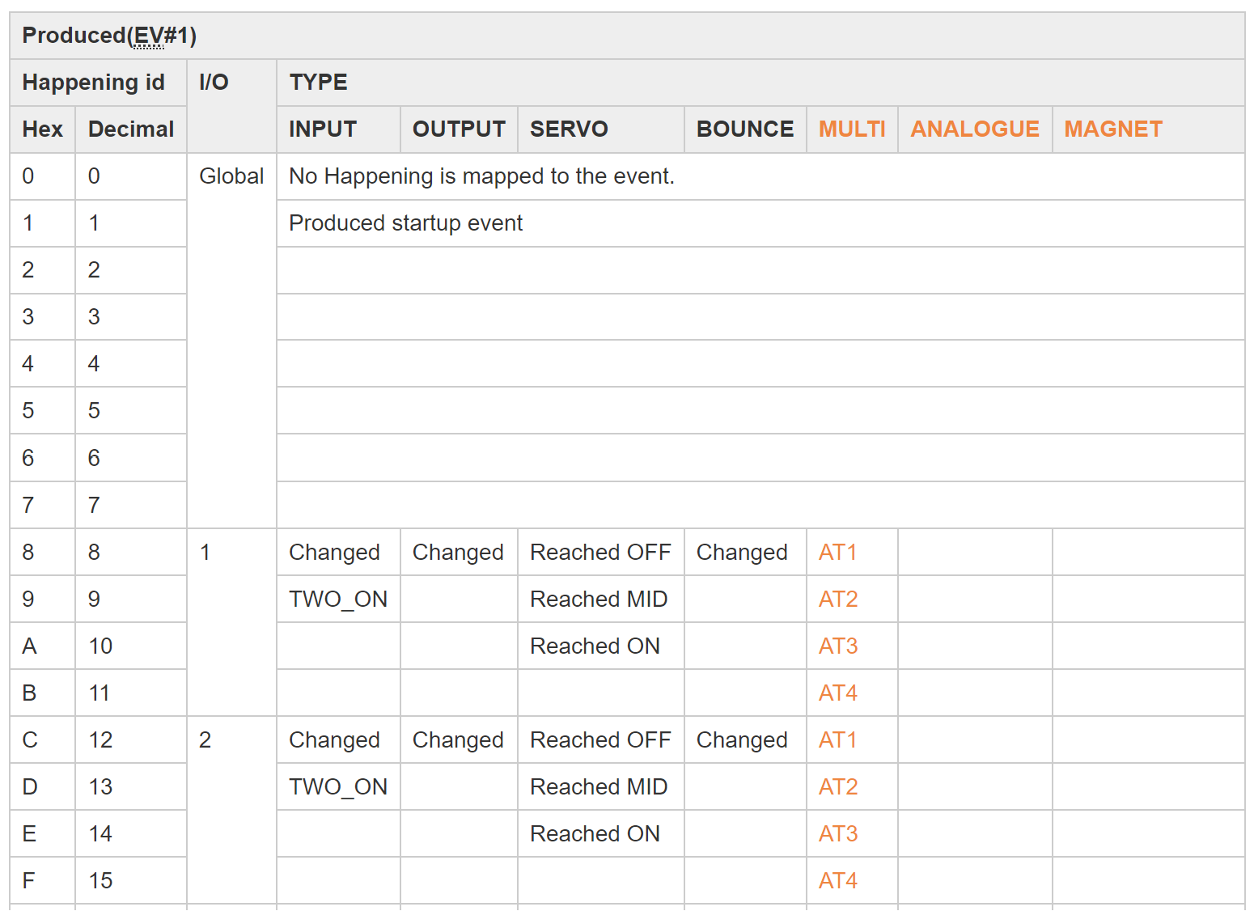
Where the variable is an encoding (i.e. each value has a different meaning), then only the label needs to be changed to describe a different meaning for that value.
This isn’t suitable for variables that aren’t encodings, hence only certain types support it.

The following element describes how to ‘overload’ the label in types that support it.
“overload”{“nv”,labels[“value”:0, “label”: “first label”, “value”:1, “label”: “2nd label”,.....]

For example, the following shows how the table above is represented
{
"type": "EventVariableSelect",
"eventVariableIndex": 1,
"displayTitle": "Produced event",
"displaySubTitle": "EV1",
"options": [
{"value": 0, "label": "no event (0)"},
{"value": 1, "label": "Startup event (1)"},
{"value": 8, "overload":{"nv": "16", "labels": [
{"value": 0, "label": "CH1 - Input Changed"},
{"value": 1, "label": "CH1 - Input Changed"},
{"value": 2, "label": "CH1 - Reached OFF"},
{"value": 3, "label": "CH1 - Input Changed"},
{"value": 4, "label": "CH1 - AT1"}
]
}
},
{"value": 9, "overload":{"nv": "16", "labels": [
{"value": 0, "label": "CH1 - TWO_ON"},
{"value": 2, "label": "CH1 - Reached MID"},
{"value": 4, "label": "CH1 - AT2"}
]
}
},
…

Logic elements
A logic element allows simple logic to be embedded into the descriptor.
The logic follows the syntax.
“Named Property”:<expression>
The logic expression returns a true or false condition when evaluated for the named property.
It is now recommended that jsonLogic is used to evaluated the expression, but compatibility with earlier versions is retained – these are both described below.

The only property currently defined is “visibilityLogic”, which if added to an element, will decide if the element is displayed depending if the expression returns true or false.
This then allows the application to show or hide an element depending on the condition of other variables, using this logic. There can thus be multiple elements for the same variable, and the logic used to determine which element to display.

jsonLogic expressions
jsonLogic is implemented in a library that supports many different programming languages.
https://jsonlogic.com/
There are numerous benefits to using this, including logical combinations (and, or etc..) and a much wider level of logical operations.
The basic syntax is
{"operator" : ["values" ... ]},
but please refer to the documentation for the actual supported operations, and the syntax for each operation.

Custom operations are used to provide access to the following node values.
EV, EVbit
NP, NPbit
NV, NVbit
Where the operations return the value of the specified variable that’s been read from the module.
The syntax for using EV is
{“EV”, <index number>}
EVbit is
{“EVbit”, [<index number>, <bit number>]}
And the same for NP and NV.

In order to differentiate these expressions from the earlier implementation, the jsonLogic expression is wrapped in a “JLL” element (json logic literal).
Here’s a simple example that tests if NV1 is equal to 9
"visibilityLogic":{ "JLL":{ "==" : [ {"NV" : [1]}, 9] } }

Here’s an example of ‘nested’ or ‘combinational’ logic that will only present true if either (or) bits 0 and 1 of EV3 are equal (‘==’) to 0 (false).
"visibilityLogic":{"JLL":{ "or" : [
{ "==" : [ {"EVbit" : [3, 0]}, false ] },
{ "==" : [ {"EVbit" : [3, 1]}, false ] }
]}
},

It’s also possible to use these new operations as parameters to each other, e.g.
"visibilityLogic":{“JLL”: { "in" : [ { "NV": {"EV" : 1}}, [5,6,7] ] } }

jsonLogic application implementation
For the application using the MDF (not the MDF itself), a little work is needed to implement this
By itself, the library is not aware of external data, such as the module variables, so the ‘add operation’ feature needs to be used to add access to this data.
The custom operations needed are
EV, EVbit
NP, NPbit
NV, NVbit
Adding operations to the library is very easy, and good examples exist in the jsonLogic documentation. It will be specific to that application, as its giving access to however that application stores its module data.

Earlier logic expression syntax
The use of this ‘home-brew’ function is now deprecated, in favour of jsonLogic (above), but should be supported for backwards compatibility.
The logic follows the syntax
“Named Property”:{ “argument”, “condition”}
The intent is that the “argument” always evaluates to a simple numeric value, and the condition just needs to compare two simple values.
For example, in the following property, “visibilityLogic”, the result of the logic element is used to control if a variable is displayed or not.
And in this case, the variable would only be displayed if the value of ev3 bit 7 is equal to 1.
"visibilityLogic":{
"evBit": {“index”:3, “bit”: 7}
"equals": 1
},

Logic conditions
condition | description
“equals”:<value> | Equal to, with numerical value, will return true or false
“in”:[<value>,...] | Equal to any value in the array, will return true or false

Logic arguments
item | Description
“evBit”: {  “index”:<ev index>,  “bit”: <0 to 7>  } | Describes a single event variable bit with numerical values for event index and bit position (0 to 7). Will evaluate to 0 or 1
“nv”:<nv index> | Describes a node variable by it’s index number, will evaluate to a number 0 to 255

Replaceable Tokens
NOTE; This replaces ‘channel names’ (below) for new MDF files
Replaceable tokens are a more ‘generic’ form of ‘channel names, and allows the use of any token name in the MDF, as the placeholder for a piece of replaceable text
This came about because a newly developed module, CANARGB, allows you to set the colour of a numbered palette using a set of 3 NV's, and the wish was to be able to name that palette, such that it could easily be identified in EV's by name, rather than having to remember the palette number.
So, the ${channelxx} token idea has been expanded to accept any token within the ${....} syntax
The token is now defined as ${<token name><token number>}, e.g. ${palette8}, ${channel6}
This is obviously compatible with the existing ${channelxx} syntax, so existing MDF’s will still be valid.
These tokens can be placed anywhere text is expected in the MDF, and the application using the MDF should replace these tokens with appropriate text.
The application should provide a user interface to enter replacement text for these tokens
Since these tokens are now arbitrary text, it’s recommended that the application processes the MDF to find out which tokens are actually being used, and the maximum number for each token name, rather than relying on a count in the actual MDF. Note this removes the need for the numberOfChannels element. This removes the need for the application to know anything about the tokens in advance

As with the channel names feature, there is a mechanism to provide default replacement text in the MDF. The syntax for this has changed from the previous ‘channel names’ feature
This is shown in the fictitious extract below, where default names for palette1 to palette16 are shown (truncated for brevity), and also default names for channel1 & channel2
"tokens": {
"palette": {
"defaultNames": {
"1": "0 : Black / off",
"2": "1 : Dark grey",
…
"15": "14 : Cyan",
"16": "15 : White"
}
},
“channel”:{
"defaultNames": {
“1”: “servo 1”
“2”: “servo 2”
}
}
},

This follows the same order of precedence as before, with the addition of checking for both the new MDF default names, and if not present, checking for the ‘old’ channel names defaults, before falling back to system default names

- User entered name for that token – stored for that layout
- MDF supplied name for that token (e.g. switch XX, LED XX, Servo XX etc..)
- Previous MDF channel names – so that existing MDF’s are usable
- System supplied default name for that token <token name><token number> - e.g. channel6, or palette8 etc..

Channel Names
This feature is now deprecated for new MDF’s – use replaceable tokens above
One of the characteristics of the majority of modules is that they support multiple input/output (I/O) ‘channels’.
By convention, these channels are numbered, but it can become a problem remembering what a particular channel (e.g. node 300, channel 2) actually connects to, especially on large networks.
The ‘channel names’ feature allows a management tool to easily replace channel ‘tokens’ in the file with user supplied names, that give more meaning (e.g. node 300, channel 2 could be named ‘turnout 1’).
If the user doesn’t choose to add a channel name, the management tool will supply a ‘system’ default in its place – this is expected to be ‘channel xx’ where xx is the channel number.

There are three aspects to this feature.

numberOfChannels’
A ‘numberOfChannels’ element to inform the management tool how many channels this module has, so it can offer the user the correct number of channels in the list to be edited.
Note that this can be omitted if the optional channel names array is used for all the channels – see below.

The token
The token itself, which is of the form ${channelxx} where xx is the channel number.
This token will then be replaced by the user entered name for that channel number, where ever it is placed in the MDF – this is expected to be used to replace fixed text fields.
The management tool should accept either case for the text ‘channel’, and also allow whitespace between ‘channel’ and the actual channel number.

channelNames array
An optional ‘channelName’ array, which will override the ‘system’ default name for the channel that is shown if there is no user name.
This is useful where the channel is a fixed I/O type, so the default can reflect that (e.g. LEDxx or Switchxx) rather than the system generic ‘channelxx’.

It is not necessary to provide a name for every channel here, e.g. you could just supply a name for channel 1 and channel 7.
Note the management tool should find the highest channel number in the channelname array, and then use either the ‘numberOfChannels’ or the highest number from this array, whichever is greater, to determine how many channel names can be edited.

The order of precedence for the channel name would then be
- User entered channel name – stored for that layout
- MDF supplied channel name (e.g. switch XX, LED XX, Servo XX etc..)
- System supplied default channel name (channel xx)

The starting fragment of an MDF is shown below, which shows the placement of the ‘numberOfChannels’, ‘channelNames’ & the first instance of a token - ${channel1}, which is used in the displayTitle element of a ‘NodeVariableSelect’ control.

{
"timestamp": "202505290839",
"moduleName": "CAN4IN4OUT",
“numberOfChannels”:8,
"channelNames": {
"1" : "Switch 1",
"2" : "Switch 2",
"3" : "Switch 3",
"4" : "Switch 4",
"5" : "LED 1",
"6" : "LED 2",
"7" : "LED 3",
"8" : "LED 4"
},
"nodeVariables": [
{
"type": "NodeVariableSelect",
"nodeVariableIndex": 1,
"displayTitle": "${channel1}",
"options": [
{
<end of fragment>

Examples
Note that much of the text used in the labels for these examples has been added for testing purposes, and is not intended to be representative of real usage.
The titles and other text are to provide clarity when testing, and don’t represent real usage.
Screenshots show implementations from the Module Management Console (MMC), and other implementations may differ in style & design.

EventVariableCollectionSelect
This shows EventVariableCollectionSelect using three event variables
In this example, if the three variables match the value for one of the labels, then that label will be shown. If there is no match, then the numeric values will be shown
The values correspond to the order of the variables in the eventVariableCollection array

{
"type": "EventVariableCollectionSelect",
"eventVariableCollection":[4,5,6],
"displayTitle": "EventVariableCollectionSelect",
"displaySubTitle": "",
"options": [
{
"label":"No Action",
"value": [0,0,0]
},{
"label":"Pair 1 Active - normal",
"value": [11,21,31]
},{
"label":"Pair 1 Active - inverted",
"value": [12,22,32]
},{
"label":"Pair 2 Active - normal",
"value": [13,23,33]
},{
"label":"Pair 2 Active - inverted",
"value": [14,24,34]
}
]
},

NodeVariableBitArray
Can also be used for event variables.
This example shows a bit array using just 4 bits in Node Variable 4.
The unused bits will remain unchanged.
Notice also this example uses the optional channel names feature.
{
"type": "NodeVariableBitArray",
"nodeVariableIndex": 4,
"displayTitle": "PORTB Pullups",
"displaySubTitle": "",
"bitCollection": [
{
"bitPosition": 0,
"label": "${channel9}"
},
{
"bitPosition": 1,
"label": "${channel10}"
},
{
"bitPosition": 4,
"label": "${channel11}"
},
{
"bitPosition": 5,
"label": "${channel12}"
}
]
}

Example screen shot of this element portrayed in MMC.
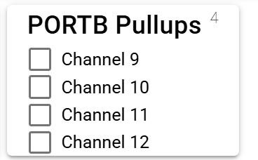

NodeVariableBitSingle
Can also be used for event variables.
This example shows the use of bit 2 from NV1, and also shows the use of ‘linkedVariables’.
‘linkedVariables’ instructs the application that these other variables are dependant on the value of this variable, hence if this changes, then it should re-read the linked variables, as they may have changed.

{
"type": "NodeVariableBitSingle",
"nodeVariableIndex": 1,
"displayTitle": "Bit 2",
"displaySubTitle": "linked 2,3,4",
"bit": 2,
"linkedVariables": {
"NV": [
2,
3,
4
]
}
},

The implementation in MMC.
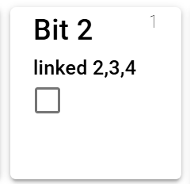

NodeVariableButtons
Node Variables only.
This example shows a collection of buttons that set a node variable to a static value, depending on which one is pressed.
Note the last entry is an optional ‘overloaded’ label element, see the overloaded labels section for more information about this optional element.
For this example, the fourth button will only be displayed if NV10 is either 0,1 or 2, with the corresponding label.
{
"displayTitle": "Button test",
"displaySubTitle": "NV22, overload using NV10",
"type": "NodeVariableButtons",
"nodeVariableIndex": 22,
"buttonCollection": [
{"label": "Min", "value": 0},
{"label": "Centre", "value": 127},
{"label": "Max", "value": 255},
{"overload":{"nv": 10, "labels": [
{"value": 0, "label": "overload 0 (5)"},
{"value": 1, "label": "overload 1 (5)"},
{"value": 2, "label": "overload 2 (5)"}]},
"value": 5}
]
},

Example screen shot of this element portrayed in MMC (NV10 = 0).
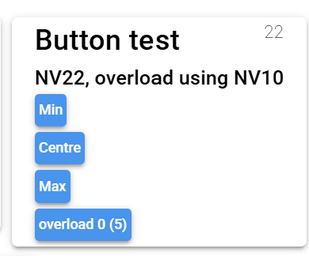

NodeVariableDual
Node variables only.
This first example shows a NodeVariableDual that is limited to 12 bits.

{
"type": "NodeVariableDual",
"nodeVariableIndexHigh": 42,
"nodeVariableIndexLow": 43,
"displayTitle": "Dual",
"displaySubTitle": "12 bits",
"startBit": 0,
"endBit": 11
}

The implementation in MMC
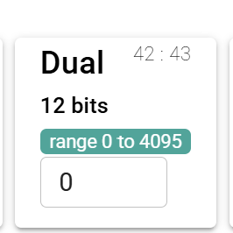

This second example shows a NodeVariableDual that uses scaling and units.

{
"type": "NodeVariableDual",
"nodeVariableIndexHigh": 42,
"nodeVariableIndexLow": 43,
"displayTitle": "Dual",
"displaySubTitle": "scaling",
"displayScale": 0.01,
"displayUnits": "mS"
},

The implementation in MMC
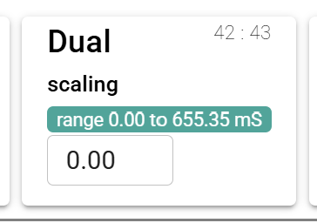

NodeVariableGroup
This can also be used with event variables.
This example shows a group ‘box’ containing two slider elements.
It also shows the use of channel name ‘tokens’, that are replaced by the application when displayed.

{
"type": "NodeVariableGroup",
"displayTitle": "${channel 1}",
"groupItems": [
{
"type": "NodeVariableSlider",
"nodeVariableIndex": 1,
"displayTitle": "Side A Pulse Duration",
"displayScale": 10,
"displayUnits": "Milli Seconds"
},
{
"type": "NodeVariableSlider",
"nodeVariableIndex": 2,
"displayTitle": "Side B Pulse Duration",
"displayScale": 10,
"displayUnits": "Milli Seconds"
}
]
},

The implementation in MMC, note that ${channel 1} has been replaced by Solenoid 1 at display time
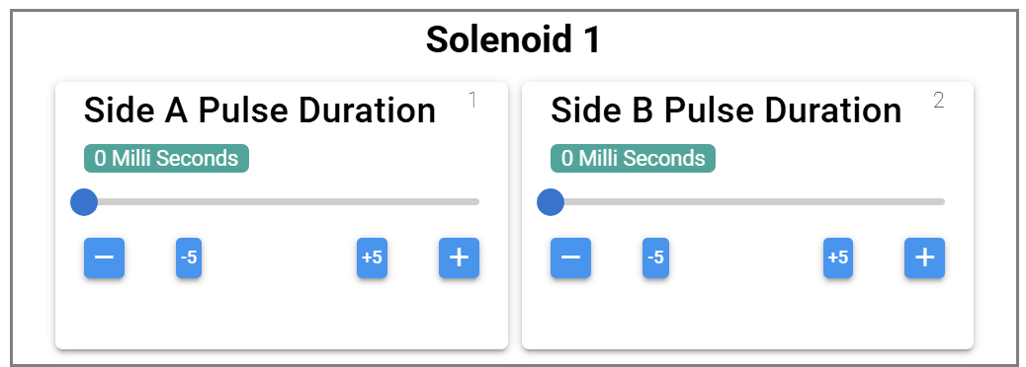

NodeVariableNumber
This can also be used with event variables.
This is also using the ‘offset’ property, which will give the displayed value the selected offset
See also NodeVariableDual for examples of the other scaling & bits options

{
"type": "NodeVariableNumber",
"nodeVariableIndex": 12,
"displayTitle": "Number - NV12",
"displaySubTitle": "offset 100",
"displayOffset": 100,
"displayUnits": "mS"
},

The implementation in MMC, that that the offset is reflected in the range displayed
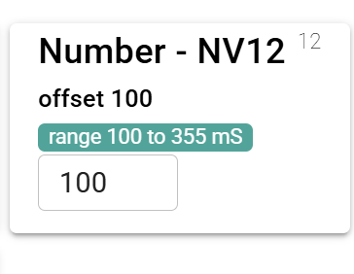
This next example shows the use of the max & min values to limit the data entry to a smaller range than the available bits

{
"type": "NodeVariableNumber",
"nodeVariableIndex": 11,
"displayTitle": "Number - NV11",
"displaySubTitle": "range 2 to 12",
"max": 12,
"min": 2
},

The implementation in MMC, that that the max & min are reflected in the range displayed
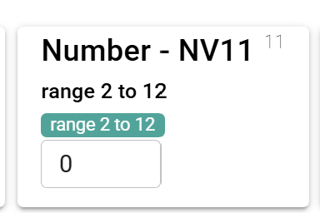

NodeVariableSlider
This can also be used with event variables.
The following example is using the first 7 bits (0 to 6), leaving bit 7 free.
Bit 7 won’t be changed.
Also note that it’s using scaling & units, a 20x factor is being applied, hence the maximum values is 127 x 20 or 2540

{
"type": "NodeVariableSlider",
"nodeVariableIndex": 1,
"displayTitle": "Pulse Duration",
"displaySubTitle": "Range 0 to 2,540 milliSeconds",
"displayScale": 20,
"displayUnits": "mS",
"startBit": 0,
"endBit": 6,
"max": 127,
"min": 0
},

The MMC implementation, showing the maximum value correctly scaled at 2540mS.
Note also the -/+ and -5/+5 buttons which allow fine grain control

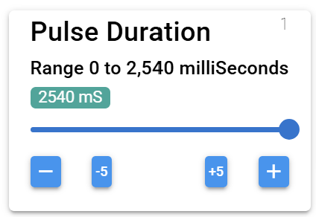

The second example is an instance for a servo
In this case (for a CANMIO-Universal), this is only displayed when the channel is set to ‘servo’ – hence there is the visibility logic element to only show this when NV16 is set to 2
There is also the ‘outputOnWrite’ element, which indicates that this variable of the node will set the output to the value written immediately (normally it would need an event to change the state of an output).
This allows features like test button, which re-writes the current value, and the ‘center’ button, that sets a static center value (127)

{
"type": "NodeVariableSlider",
"comment": "servo type only",
"visibilityLogic": {
"nv": 16,
"equals": 2
},
"nodeVariableIndex": 18,
"displayTitle": "OFF position",
"displaySubTitle": "servo specific",
"displayUnits": "steps",
"outputOnWrite": true
},

The MMC implementation, showing the center & test buttons that are only present when ‘outputOnWrite’ is true
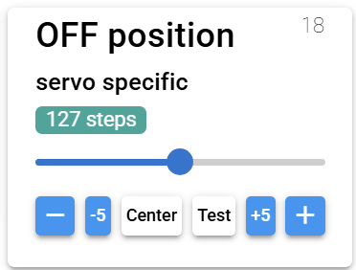

NodeVariableSelect
This can also be used with event variables.
This example shows the use in allowing the setting of the I/O channel type for a CANMIO, and uses a channel name token for the main title.
It also uses ‘linkedVariables’, this is necessary, as the other variables associated with this channel are reset to defaults by the node itself depending on the I/O type set in this variable, so they need to be re-read.

{
"displayTitle": "${channel1}",
"items": [
{
"type": "NodeVariableSelect",
"nodeVariableIndex": 16,
"displayTitle": "I/O type",
"displaySubTitle": "",
"options": [
{
"label": "INPUT",
"value": 0
},
{
"label": "OUTPUT",
"value": 1
},
{
"label": "SERVO",
"value": 2
},
{
"label": "BOUNCE",
"value": 3
},
{
"label": "MULTI",
"value": 4
}
],
"linkedVariables": {
"NV": [
17,
18,
19,
20,
21,
22
]
}
},

MMC implementation
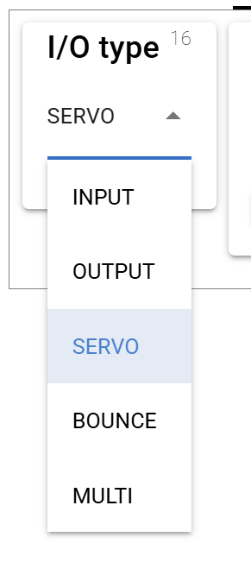

NodeVariableTabs
This can also be used with event variables.
This is a more complex example, with on element in the first tab ‘panel’, and two groups inside the second ‘panel’, with two elements inside each of these two groups
Tabs can also be put inside groups
There are two screen shots following this that better describe the effect
{
"type": "NodeVariableTabs",
"tabPanels": [
{
"displayTitle": "Single Bit",
"displaySubTitle": "Tab: Warning Will Robinson........",
"items": [
{
"type": "NodeVariableBitSingle",
"nodeVariableIndex": 2,
"displayTitle": "Bit 0",
"displaySubTitle": "NV2",
"bit": 0
}
]
},
{
"displayTitle": "Group test",
"items": [
{
"type": "NodeVariableGroup",
"displayTitle": "Group 1",
"groupItems": [
{
"type": "NodeVariableBitArray",
"nodeVariableIndex": 1,
"displayTitle": "Bit Array",
"displaySubTitle": "NV1",
"bitCollection": [
{
"bitPosition": 0,
"label": "${channel 1}"
},
{
"bitPosition": 1,
"label": "${channel 2}"
},
{
"bitPosition": 2,
"label": "${channel 3}"
},
{
"bitPosition": 3,
"label": "${channel 4}"
},
{
"bitPosition": 4,
"label": "${channel 5}"
},
{
"bitPosition": 5,
"label": "${channel 6}"
},
{
"bitPosition": 6,
"label": "${channel 7}"
},
{
"bitPosition": 7,
"label": "${channel 8}"
}
]
},
{
"type": "NodeVariableBitSingle",
"nodeVariableIndex": 2,
"displayTitle": "Bit 0",
"displaySubTitle": "NV2",
"bit": 0
}
]
},
{
"type": "NodeVariableGroup",
"displayTitle": "Group 2",
"groupItems": [
{
"type": "NodeVariableSelect",
"nodeVariableIndex": 6,
"displayTitle": "Select",
"displaySubTitle": "NV6",
"options": [
{
"label": "Options 1",
"value": 0
},
{
"label": "Options 2",
"value": 1
},
{
"label": "Options 3",
"value": 2
},
{
"label": "Options 4",
"value": 8
}
]
},
{
"type": "NodeVariableSlider",
"nodeVariableIndex": 7,
"displayTitle": "Slider",
"displaySubTitle": "tab group slider",
"badge": "Delay",
"displayScale": 1,
"displayUnits": "Milli Seconds",
"max": 255,
"min": 0
}
]
}
]
}
]
},

The MMC implementation, showing the view when each tab is selected.